"Battle for the Aegis"
Characters: Captain, Alien Prisoner, Crew Member, Science Officer, Medical Officer, Chief Scientist, Engineer, Chemist.
In the vast expanse of space, aboard the starship "Aegis," humanity voyages into the unknown, seeking the wonders of distant galaxies. But with discovery comes danger, and on one fateful mission, the crew of the "Aegis" finds themselves under attack. An alien entity, fueled by malevolence and revenge, launches a relentless assault on the ship, seeking to conquer and destroy. Through courage and determination, the crew fights back, capturing the nefarious alien and locking it away in the detention center. The crew celebrated their victory with a customary water chugging party, but they will soon learn that their celebrations were premature. There is still danger afoot. The tale of survival, wit, and intergalactic justice begins.
[Scene 1: The Spaceship Command Center]
Crew Member: (rubbing temples, feeling uneasy) Something doesn't feel right. My head... it's pounding.
[The crew member clutches their stomach, wincing in pain. A wave of dizziness washes over them as the symptoms of arsenic poisoning begin to take hold.]
Crew Member: (whispering to themselves) What's happening to me? Is anyone else feeling this way?
[The room seems to spin as the crew member struggles to maintain balance. The subtle onset of nausea accompanies the growing discomfort.]
Crew Member: (voice shaky) Captain... something's wrong. I feel... terrible. It's like my body's betraying me.
[The crew member's distress is palpable, a foreboding sign of the impending crisis aboard the spaceship.]
Captain: (frowning) Something's not right. Our water supply systems are malfunctioning.
Science Officer: (checking readings) Captain, it appears the water has been poisoned with arsenic!
Crew Member: (panicked) The water is what now?! We had a water chugging party just an hour ago. We all drank from the same supply, and I took a bet to drink twice as much! This must be connected to my symptoms.
Medical Officer: (calming the crew member) The effects of arsenic poisoning can be severe, but if we act quickly, we can figure out a way to neutralize the arsenic in our systems and prevent any further harm… If only we knew how arsenic affected the body.
Crew Member: (still panicked and now throwing up) What do you mean doc? You’re telling me you went through 10 years of schooling at the medical academy, and you don’t know what arseni—BLeCh (throwing up noises).
Medical Officer: Well, I am only human and therefore am not all-knowing about the vast array of toxic substances and what they do. What I do know is that when I understand what cellular process it affects, I will know how to cure you.
[The crew member, though fearful, finds a glimmer of hope in the medical officer's assurance, and the crew rallies together to face the crisis.]
[Scene 2: Detention Center]
Captain: You have cleverly poisoned the crew with arsenic alien. Before we meet our demise, we would like to know what exactly this poison will do to our bodies! Since you are obviously so much smarter than us, would you care to explain it to our simple minds?
Alien Prisoner: (smirking, sinister) Ah, the sweet taste of impending doom, captain. Allow me to enlighten you. Arsenic poisoning is a meticulous assassin. It infiltrates your cells, disrupting the delicate ballet of biochemical reactions. First, it sabotages glycolysis by targeting the phosphofructokinase enzyme, also called PFK, the very heart of your precious glycolysis.
Captain: (listening intently) Go on.
Alien Prisoner: Through a diabolical process, arsenic also induces hemolysis, causing your precious red blood cells to rupture. In this chaos, phosphorylation of ADP, a crucial step in the creation of ATP, is hindered. Your cells, starved of energy, wither and falter. It's a dance of death, a macabre symphony where your very life force is snuffed out.
[The crew listens in horror, realizing the gravity of the threat they face.]
Captain: (narrowing eyes) What will happen if the PFK enzyme is inhibited at the same time as hemolysis?
Alien Prisoner: (grinning malevolently) Your cells will starve, cut off from their energy source. Muscles will weaken, organs will fail, and your bodies will wither away in pain. Suffocation from within, you see. It's a slow and agonizing death, my dear humans.
Captain: (smirking back) Your malevolence has blinded you, alien. By revealing your sinister plot, you inadvertently gave us the knowledge we needed to save ourselves. Thanks to your arrogance, we know how to counteract the effects of arsenic poisoning.
Alien Prisoner: (eyes widening in realization) You might survive this, but you won't escape the clutches of my evil crew. My imprisonment won't go unpunished.
Captain: (calmly) Justice will be served, and you will answer for your crimes. But first, my priority is the safety of my crew. We will overcome this with SCIENCE, and your plan will fail. Your arrogance led to your own downfall, alien. We will not succumb to your malevolence. Humanity prevails in the face of adversity. Prepare to face the consequences of your actions at the intergalactic court, where your reign of terror ends.
[The captain stands tall, resolute, as the alien prisoner seethes with frustration, realizing the tables have turned.]
BREAK FOR LECTURE ON GLYCOLYSIS
[Scene 3: Spaceship Laboratory]
Chief Scientist: (examining water samples) Arsenic levels are dangerously high. We need to act fast.
Medical Officer: (explaining to crew, urgently) According to the Alien, Arsenic inhibits the PFK enzyme in our cells, a crucial player in glycolysis—the process our bodies use to break down glucose for energy. In glycolysis, PFK catalyzes the conversion of fructose-6-phosphate to fructose-1,6-bisphosphate. This step is like a gateway, determining the fate of glucose: either it continues down the pathway, providing energy for our cells, or it stagnates, depriving our cells of potential energy.
Engineer: So, if the PFK enzyme is inhibited, our cells can't produce energy efficiently. We need energy for everything—our organs, muscles, and even basic bodily functions. If this process is disrupted, our entire system could shut down.
Medical Officer: Exactly. As the prisoner said, without immediate intervention, the lack of energy production can lead to organ failure, muscle weakness, and eventually, death. We must eliminate the arsenic from our systems and restore the PFK enzyme's function before it's too late.
[The urgency in the room intensifies as the crew realizes the gravity of the situation.]
[Scene 4: Science Lab]
Chemist: (excitedly) I've formulated a chelating agent in the synthesizer called dimercaptosuccinic acid (DMSA). It can enter the cytoplasm where glycolysis occurs and bind to arsenic, neutralizing its effects.
Engineer: Let's also modify the water filtration systems to use reverse osmosis. It should help remove the arsenic from our water.
[Scene 5: Spaceship Water Treatment Room]
Crew Member: (working on the filtration system) Reverse osmosis in progress. Arsenic levels dropping.
Captain: Good work, everyone. Now we just need to wait for the chelate to neutralize the arsenic in our bodies.

[Scene 6: Medical Bay]
Medical Officer: (monitoring crew) PFK enzyme activity has returned to normal. The chelates have successfully neutralized the arsenic's effects on glycolysis. But we're not out of the woods yet. The hemolysis caused by arsenic has left our crew weary and oxygen transport compromised.
BREAK: WHAT WOULD YOU DO? Now that we are inside the mitochondria, oxygen is a major factor… Introduce Pyruvate linkage, Krebs and explain the ETC briefly (harvesting)
Captain: (concerned) What can we do to restore their energy and vitality?
Medical Officer: (determined) I recommend blood transfusions. By replenishing the lost red blood cells, we'll restore oxygen transport, helping everyone regain their strength more quickly.
[The medical team swiftly administers blood transfusions to the crew members. The weary faces slowly transform as color returns to their cheeks, and energy flickers back into their eyes.]
Crew Member: (feeling revitalized) I can feel the difference already. Thank you, Doctor.
Medical Officer: (smiling) Rest and recovery are crucial now. With the return of proper oxygen transport, your bodies can heal more effectively. We've overcome the worst of it. Now, we rebuild our strength and stand ready to face any challenges that lie ahead.
[The crew, though weary, shares glimmers of hope and determination. The medical bay becomes a symbol of resilience, where life forces are renewed, and the crew unites in their determination to face the remaining challenges together.]
[Scene 7: Spaceship Command Center]
Captain: (addressing crew) We've faced a deadly threat, but we've overcome it together through our wits and through science! Now, let's find out how that alien prisoner managed to poison our water. We need to ensure it doesn't happen again.
[Curtains Close]
A note: In the conclusion of our gripping tale, "Battle for the Aegis," we witness the triumph of human ingenuity over an insidious threat. The effects of arsenic poisoning portrayed in this story—headaches, abdominal pain, dizziness, and nausea/vomiting—are all too real, reflecting the genuine dangers posed by this deadly substance.
Throughout history, medical professionals have devised various methods to combat arsenic poisoning. The depiction of medical interventions in our story mirrors real-life practices aimed at counteracting arsenic's impact.
As our characters emerge victorious, let this narrative stand as a testament to the resilience of the human spirit and the power of scientific knowledge. In the face of adversity, understanding, innovation, and unwavering determination can conquer even the most formidable foes. Let this story inspire hope and appreciation for the remarkable strides made in the field of medicine, guiding us toward a safer and healthier future.
Worksheet: Glycolysis, the Krebs cycle, and Arsenic Poisoning in "Battle for the Aegis"
Instructions: Read the excerpts from the play and answer the following questions related to glycolysis and its disruption due to arsenic poisoning. There will also be questions based on glycolysis, the CoA linkage reaction, and the Krebs cycle.

QUESTIONS ON GLYCOLYSIS

MODEL 1

"Arsenic inhibits the PFK enzyme in our cells, a crucial player in glycolysis—the process our bodies use to break down glucose for energy. In glycolysis, PFK catalyzes the conversion of fructose-6-phosphate to fructose-1,6-bisphosphate. This step is like a gateway, determining the fate of glucose: either it continues down the pathway, providing energy for our cells, or it stagnates, depriving our cells of potential energy."
EXCERPT 1
- What is the main function of glycolysis in a cell. Refer to Excerpt 1.

- Does the process of glycolysis require an input of energy? Provide specific evidence from model 1 to support your answer.

- Which enzyme is inhibited by arsenic in glycolysis, as mentioned in the excerpt? What would happen if this enzyme was inhibited? Refer to Excerpt 1

- How does the cell use phosphates to break glucose in half? What molecules does it end up with immediately after glucose is broken?

- How many pyruvate molecules are made from each glucose molecule?

- What is the net gain of each of the following molecules for Glycolysis for each molecule of glucose.
CO2: ______________
ATP: ______________
NADH: ______________
FADH2: ______________

QUESTIONS ON THE CO-ENZYME LINK REACTION:

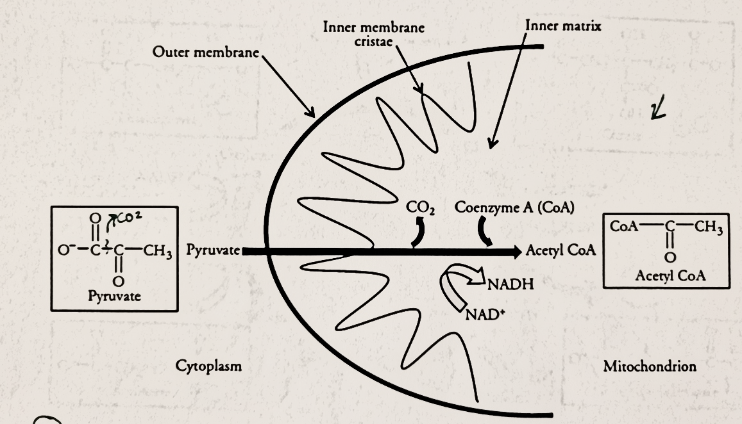

MODEL 2

- According to model 2, where in a cell does a link reaction take place? Be specific when talking about the precise location of the reaction.

- Is the pyruvate molecule likely to move across the mitochondrial membranes by diffusion? (think about its’ charge and size)

- During the link reaction, the pyruvic acid molecule is decarboxylated. What molecule is removed during this process?

- CoA carries the remainder of the decarboxylated pyruvate molecule to the site of the Krebs cycle. What is the name of this decarboxylated pyruvate? What would happen to the pyruvate if the enzyme simply “snipped off” the carboxyl group and did not attach to the R group?

- How many carbons of the molecule remain when it is attached to CoA?

- What is the net gain of each of the following molecules for the link reaction for each molecule of pyruvate?
CO2: ______________
ATP: ______________
NADH: ______________
FADH2: ______________

QUESTIONS ON THE REMAINDER OF CELLULAR RESPIRATION (Krebs Cycle & ETC):
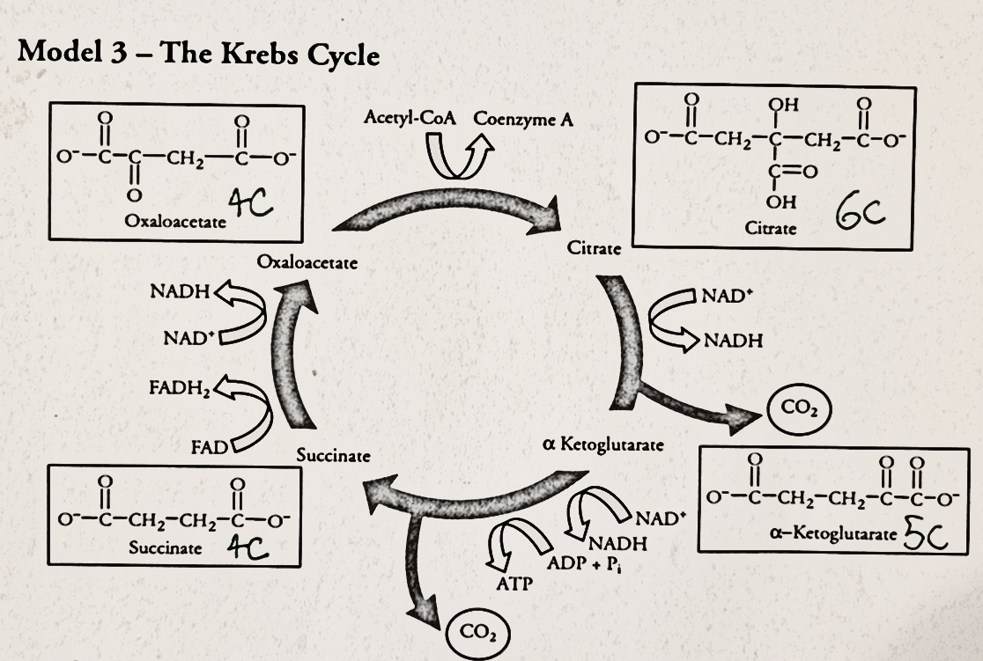

MODEL 3

EXCERPT 2
"Arsenic poisoning is a meticulous assassin. It infiltrates your cells, disrupting the delicate ballet of biochemical reactions. First, it sabotages glycolysis by targeting the PFK enzyme, the very heart of your energy production."

- Explain how arsenic also affects the Krebs Cycle by targeting the PFK enzyme in glycolysis, as mentioned in the excerpt. Be sure to make the connection between the products of glycolysis and the starting step of cellular respiration. Refer to excerpt 2

- What are the consequences of inhibiting the PFK enzyme for the cell and the organism? Refer to excerpt 2.

- Compare the oxaloacetate molecule with the citrate molecule:
  - How many carbon atoms are in oxaloacetate? _______
  - How many carbon atoms are in citrate? ________
  - Where did the extra carbon atoms come from to convert oxaloacetate into citrate? Hint: 2 carbon molecules were added to Oxaloacetate
- Throughout the Krebs cycle, there are three different “dead battery” molecules that become like “charged batteries” when they are reduced. Name these molecules and in addition to this, group them as either “reduced” or “oxidized.”
Reduced | Oxidized

- Which molecule in the Krebs cycle has the highest potential energy: Citrate, alpha-ketoglutarate, succinate, or oxaloacetate? Provide specific evidence from Model 3 to support your answer.

- How many turns of the Krebs cycle occur for every glucose molecule that undergoes cellular respiration?

- What is the net gain of each of the following molecules for the Krebs Cycle for each molecule of pyruvate?
CO2: ______________
ATP: ______________
NADH: ______________
FADH2: ______________

- What is the total net gain of each of the following molecules in glycolysis, the CoA link reaction, and the Krebs cycle for each molecule of glucose? (read this question carefully!)

CO2: ______________
ATP: ______________
NADH: ______________
FADH2: ______________

“I recommend blood transfusions. By replenishing the lost red blood cells, we'll restore oxygen transport, helping everyone regain their strength more quickly.”
EXCERPT 3

11.Explain how the blood transfusion contributed to increased energy levels in the crew members after the arsenic poisoning incident, considering the role of cellular respiration and ATP production. (Hint: The part of cellular respiration that requires oxygen was mentioned during lecture). Refer to excerpt 3.

- Look at the following formulas:
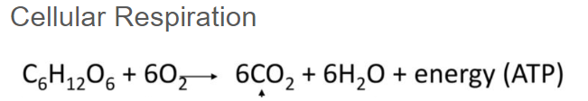

These two chemical reactions have the same types of reactants and products… Strange.
- Why doesn’t our body break all the bonds of the sugar at once like in a combustion reaction? How would doing this affect the organism?

If you have time and want to learn something new! (optional): Research these questions using the internet.
“I've formulated a chelating agent in the synthesizer called dimercaptosuccinic acid (DMSA). It can enter the cytoplasm where glycolysis occurs and bind to arsenic, neutralizing its effects.”
- Research and write a summary of what a chelating agent is and how it is used in modern medicine. Refer to the excerpt above.

"Reverse osmosis in progress. Arsenic levels dropping."
- Do some research on the internet and draw a diagram of how reverse osmosis is performed. Use arrows to indicate movement of H2O. Refer to the excerpt above.

